Advanced Keylogger Detector – Complete Project Documentation

Project Overview
Advanced Keylogger Detector
A Cybersecurity Project (Working Prototype)
Introduction:
• Keyloggers are malicious programs that record keystrokes secretly.
• They are widely used for stealing passwords, banking details, and personal data.
• Our project detects suspicious processes and alerts the user.
• It provides logs and a user-friendly GUI.
Objectives:
System Architecture:
1. User interacts with GUI (Tkinter).
2. Process Scanner checks all running processes.
3. Keylogger Detector analyzes behavior patterns.
4. Logger saves suspicious activity.
5. User views alerts and logs.
Modules:
• main.py – GUI and main controller.
• process_scan.py – Scans running processes.
• keylogger_detect.py – Detects suspicious keylogger activities.
• logger.py – Maintains suspicious logs.
Workflow:
1. Start Application.
2. User clicks 'Scan System'.
3. Suspicious processes detected.
4. Alerts displayed.
5. Logs saved.
6. User can view logs later.

README.md
# Advanced Keylogger Detector (AKD)
**Description**
Advanced Keylogger Detector is a Python-based desktop utility that monitors running processes,
checks for suspicious behavior commonly associated with keyloggers (heuristic checks),
monitors clipboard access, and provides a friendly GUI to alert users and optionally terminate
suspicious processes.
**What's included**
- `main.py` - Launches the attractive Tkinter GUI and ties everything together.
- `utils/process_scan.py` - Scans running processes using psutil and flags suspicious ones.
- `utils/keylogger_detect.py` - Heuristic checks to detect likely keylogger behavior.
- `utils/logger.py` - Handles logging suspicious events to `logs/suspicious.log`.
- `assets/` - Contains a generated background image used by the GUI.
- `requirements.txt` - Python dependencies.
- `README.md` - This file.
**How to run**
1. Create a virtual environment (recommended):
```bash
python -m venv venv
source venv/bin/activate # on Windows use: venv\Scripts\activate
pip install -r requirements.txt
```
2. Run the app:
```bash
python main.py
```
**Notes & Safety**
- This project uses heuristic detection — it *simulates* keystroke-hook detection for educational/demonstration use.
- Do NOT use this tool for malicious purposes.
- Tested on Windows and Linux (requires `psutil` and `pynput` for full functionality).

requirements.txt
psutil
pynput
Pillow

process_scan.py
import psutil
import time
SUSPICIOUS_KEYWORDS = ['key', 'logger', 'log', 'clip', 'spy', 'monitor', 'capture', 'hook']
def list_processes():
procs = []
for p in psutil.process_iter(['pid', 'name', 'exe', 'cpu_percent', 'username']):
try:
procs.append(p.info)
except (psutil.NoSuchProcess, psutil.AccessDenied):
continue
return procs
def heuristic_flag_process(proc_info):
name = (proc_info.get('name') or '').lower()
exe = (proc_info.get('exe') or '') .lower()
cpu = proc_info.get('cpu_percent') or 0
score = 0
for kw in SUSPICIOUS_KEYWORDS:
if kw in name or kw in exe:
score += 2
# unusually high CPU for small processes can be suspicious
if cpu and cpu > 30:
score += 1
return score
def find_suspicious_processes(threshold=2):
suspects = []
for p in psutil.process_iter(['pid', 'name', 'exe', 'cpu_percent', 'username']):
try:
info = p.info
score = heuristic_flag_process(info)
if score >= threshold:
info['score'] = score
suspects.append(info)
except (psutil.NoSuchProcess, psutil.AccessDenied):
continue
return suspects

main.py
import tkinter as tk
from tkinter import ttk, messagebox
from pathlib import Path
import threading
import time
import psutil
from utils.process_scan import list_processes, find_suspicious_processes
from utils.keylogger_detect import start_keystroke_monitor
from utils.logger import log_suspicious
from PIL import Image, ImageTk
APP_ROOT = Path(__file__).resolve().parent
class AKDApp:
def __init__(self, root):
self.root = root
root.title("Advanced Keylogger Detector")
root.geometry("900x600")
root.resizable(False, False)
# Top banner with generated image
banner_path = APP_ROOT / 'assets' / 'bg_banner.png'
img = Image.open(banner_path).resize((900,140))
self.banner_img = ImageTk.PhotoImage(img)
banner = ttk.Label(root, image=self.banner_img)
banner.place(x=0, y=0)
# Main frame
main = ttk.Frame(root, padding=12)
main.place(x=10, y=150, width=880, height=430)
# Left: Processes list
left = ttk.Frame(main)
left.place(x=0, y=0, width=540, height=420)
ttk.Label(left, text="Running Processes", font=(None, 12, 'bold')).pack(anchor='w')
cols = ('pid','name','cpu','user')
self.tree = ttk.Treeview(left, columns=cols, show='headings', height=18)
for c in cols:
self.tree.heading(c, text=c.title())
self.tree.column(c, width=120)
self.tree.pack(fill='both', expand=True, pady=(6,0))
# Right: Controls & Suspects
right = ttk.Frame(main)
right.place(x=560, y=0, width=320, height=420)
ttk.Label(right, text="Controls", font=(None, 12, 'bold')).pack(anchor='w')
ttk.Button(right, text="Refresh Processes", command=self.refresh_processes).pack(fill='x', pady=6)
ttk.Button(right, text="Run Quick Scan", command=self.run_quick_scan).pack(fill='x', pady=6)
ttk.Button(right, text="Start Demo Keystroke Monitor", command=self.start_demo_keystroke).pack(fill='x', pady=6)
ttk.Button(right, text="Open Logs", command=self.open_logs).pack(fill='x', pady=6)
ttk.Label(right, text="Suspicious Processes", font=(None, 12, 'bold')).pack(anchor='w', pady=(12,0))
self.suspect_box = tk.Listbox(right, height=10)
self.suspect_box.pack(fill='both', expand=True, pady=(6,0))
ttk.Button(right, text="Terminate Selected", command=self.terminate_selected).pack(fill='x', pady=6)
# Status bar
self.status_var = tk.StringVar(value='Ready')
status = ttk.Label(root, textvariable=self.status_var, relief='sunken', anchor='w')
status.place(x=0, y=580, width=900)
# populate once
self.refresh_processes()
def refresh_processes(self):
self.status_var.set('Refreshing process list...')
for i in self.tree.get_children():
self.tree.delete(i)
try:
procs = list_processes()
for p in procs:
self.tree.insert('', 'end', values=(p.get('pid'), p.get('name'), p.get('cpu_percent'), p.get('username')))
self.status_var.set(f'Loaded {len(procs)} processes.')
except Exception as e:
self.status_var.set('Error refreshing processes.')
messagebox.showerror('Error', str(e))
def run_quick_scan(self):
self.status_var.set('Running quick heuristic scan...')
self.suspect_box.delete(0, 'end')
def _scan():
suspects = find_suspicious_processes()
if not suspects:
messagebox.showinfo('Scan Result', 'No suspicious processes found by heuristics.')
else:
for s in suspects:
display = f"PID:{s.get('pid')} | {s.get('name')} | score={s.get('score')}"
self.suspect_box.insert('end', display)
log_suspicious(f"Suspect found: {display}")
self.status_var.set('Scan complete.')
t = threading.Thread(target=_scan, daemon=True)
t.start()
def start_demo_keystroke(self):
self.status_var.set('Starting demo keystroke monitor for 10 seconds...')
start_keystroke_monitor(duration=10)
messagebox.showinfo('Demo', 'Keystroke demo monitor started for 10 seconds. (Type to generate activity)')
self.status_var.set('Demo monitor running...')
def open_logs(self):
logs = APP_ROOT / 'logs' / 'suspicious.log'
if logs.exists():
try:
if os.name == 'nt':
os.startfile(str(logs))
else:
import subprocess
subprocess.run(['xdg-open', str(logs)])
except Exception as e:
messagebox.showinfo('Logs path', str(logs))
else:
messagebox.showinfo('Logs', 'No logs yet.')
def terminate_selected(self):
sel = self.suspect_box.curselection()
if not sel:
messagebox.showwarning('Select', 'Please select a suspicious entry to terminate.')
return
entry = self.suspect_box.get(sel[0])
try:
pid = int(entry.split('|')[0].split(':')[1].strip())
except:
messagebox.showerror('Parse', 'Could not parse PID from entry.')
return
try:
p = psutil.Process(pid)
p.terminate()
messagebox.showinfo('Terminated', f'Process {pid} terminated (requested).')
log_suspicious(f'User requested termination of PID {pid}')
self.run_quick_scan()
except Exception as e:
messagebox.showerror('Error', str(e))
if __name__ == '__main__':
root = tk.Tk()
style = ttk.Style(root)
# Try to use a modern theme if available
try:
style.theme_use('clam')
except:
pass
app = AKDApp(root)
root.mainloop()

logger.py
import logging
from pathlib import Path
logs_dir = Path(__file__).resolve().parents[1] / "logs"
logs_dir.mkdir(exist_ok=True)
log_path = logs_dir / "suspicious.log"
logger = logging.getLogger("AKD")
logger.setLevel(logging.INFO)
handler = logging.FileHandler(log_path, encoding='utf-8')
formatter = logging.Formatter('%(asctime)s - %(levelname)s - %(message)s')
handler.setFormatter(formatter)
logger.addHandler(handler)
def log_suspicious(message):
logger.warning(message)

keylogger_detect.py
# This module provides simulated detection helpers.
# Real keystroke hook detection requires OS-level hooks and elevated privileges.
# For educational purposes we use heuristics and pynput to demonstrate.
import threading
import time
from pynput import keyboard
from pathlib import Path
from .logger import log_suspicious
_keystroke_activity = {
'count': 0,
'last_time': None
}
_monitoring = False
def _on_press(key):
_keystroke_activity['count'] += 1
_keystroke_activity['last_time'] = time.time()
def start_keystroke_monitor(duration=10):
"""Start a short background monitor to count keystrokes (simulation)."""
global _monitoring, _keystroke_activity
if _monitoring:
return
_monitoring = True
_keystroke_activity = {'count': 0, 'last_time': None}
listener = keyboard.Listener(on_press=_on_press)
listener.start()
# run for `duration` seconds in a separate thread then stop
def _run_and_stop():
time.sleep(duration)
try:
listener.stop()
except:
pass
# heuristic: if many keystrokes observed quickly, log as suspicious (demo)
if _keystroke_activity['count'] > 30:
log_suspicious(f"High keystroke activity observed during demo monitor: count={_keystroke_activity['count']}")
t = threading.Thread(target=_run_and_stop, daemon=True)
t.start()

SUMMARY
Advanced Keylogger Detector
A Cybersecurity Project (Working Prototype)
Introduction:
• Keyloggers are malicious programs that record keystrokes secretly.
• They are widely used for stealing passwords, banking details, and personal data.
• Our project detects suspicious processes and alerts the user.
• It provides logs and a user-friendly GUI.
Objectives:
System Architecture:
1. User interacts with GUI (Tkinter).
2. Process Scanner checks all running processes.
3. Keylogger Detector analyzes behavior patterns.
4. Logger saves suspicious activity.
5. User views alerts and logs.
Modules:
• main.py – GUI and main controller.
• process_scan.py – Scans running processes.
• keylogger_detect.py – Detects suspicious keylogger activities.
• logger.py – Maintains suspicious logs.
Workflow:
1. Start Application.
2. User clicks 'Scan System'.
3. Suspicious processes detected.
4. Alerts displayed.
5. Logs saved.
6. User can view logs later.

Screenshots:
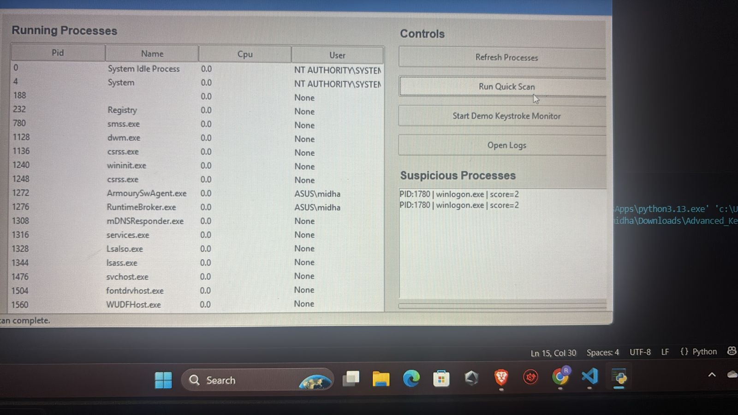
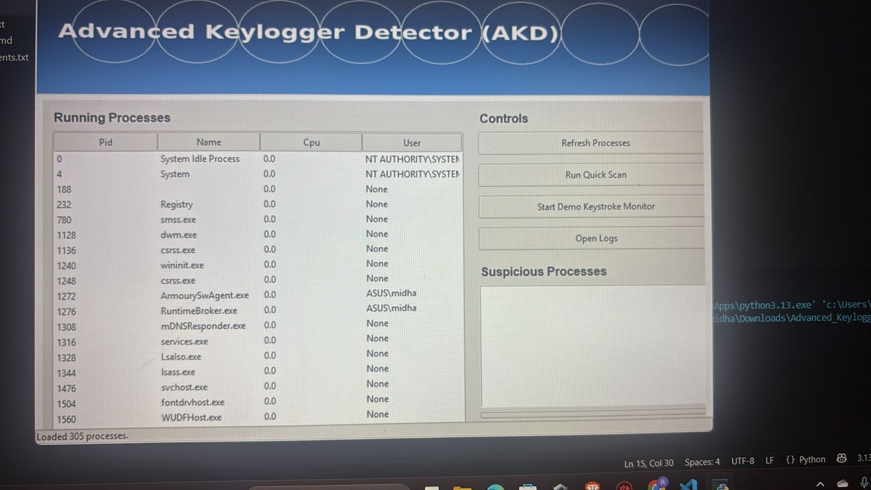
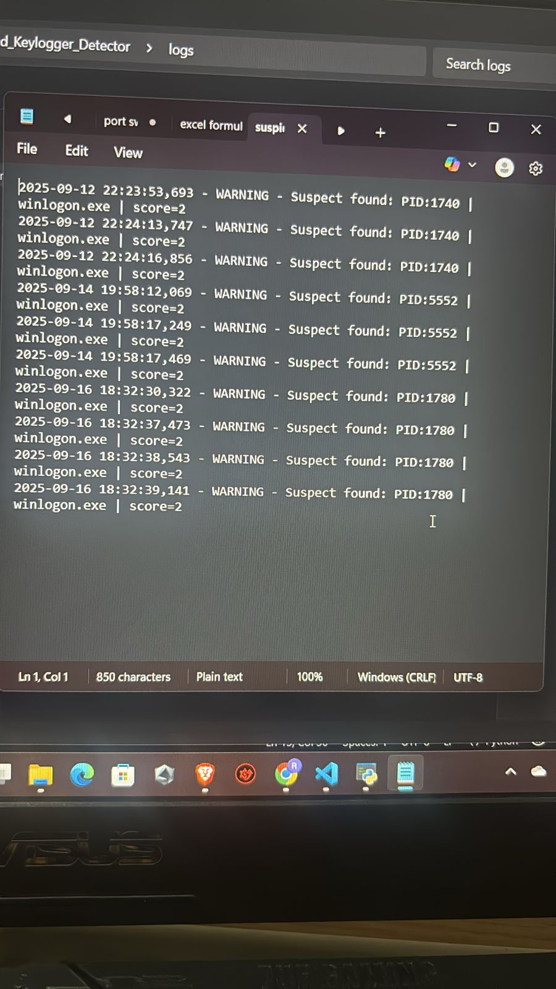
-by
Sarthaka Subhankara Singh
Intern ID : 438
(made under Digisuraksha Parhari Foundation)

